PF - LAB
CHALLENGE 0
Problem 1
Print the following triangles and their hollow versions.
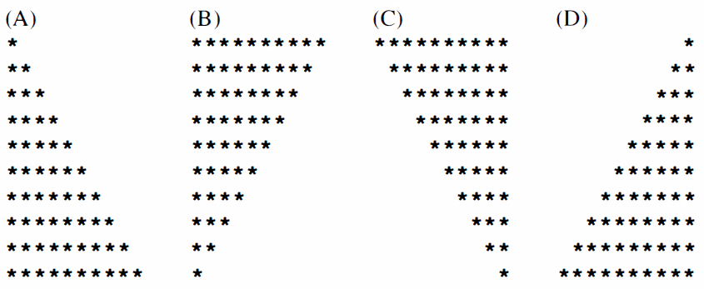
Problem 2 (Equilateral Triangle - Filled and Hollow)
Write a program which takes input from the user, the height H and then prints the filled and hollow equilateral triangle shape corresponding to the entered input.
Sample Input: H = 6
Sample Output:
*  * * *  * * * * *  * * * * * * *  * * * * * * * * *  * * * * * * * * * * * | *  * * *  * * * * *  * * * * * * *  * * * * * * * * *  * * * * * * * * * * *
Problem 3 (Diamond - Filled and Hollow)
Write a program which takes input from the user, the height H of the Diamond and then prints the diamond shape (filled and hollow) corresponding to the entered input.
Sample Input: H = 4
Sample Output:
*  * * *  * * * * *  * * * * * * *  * * * * *  * * *  * | *  * *  * *  * *  * *  * *  *

CHALLENGE 1 (Pajamas)
Part 1 - Print the following shapes
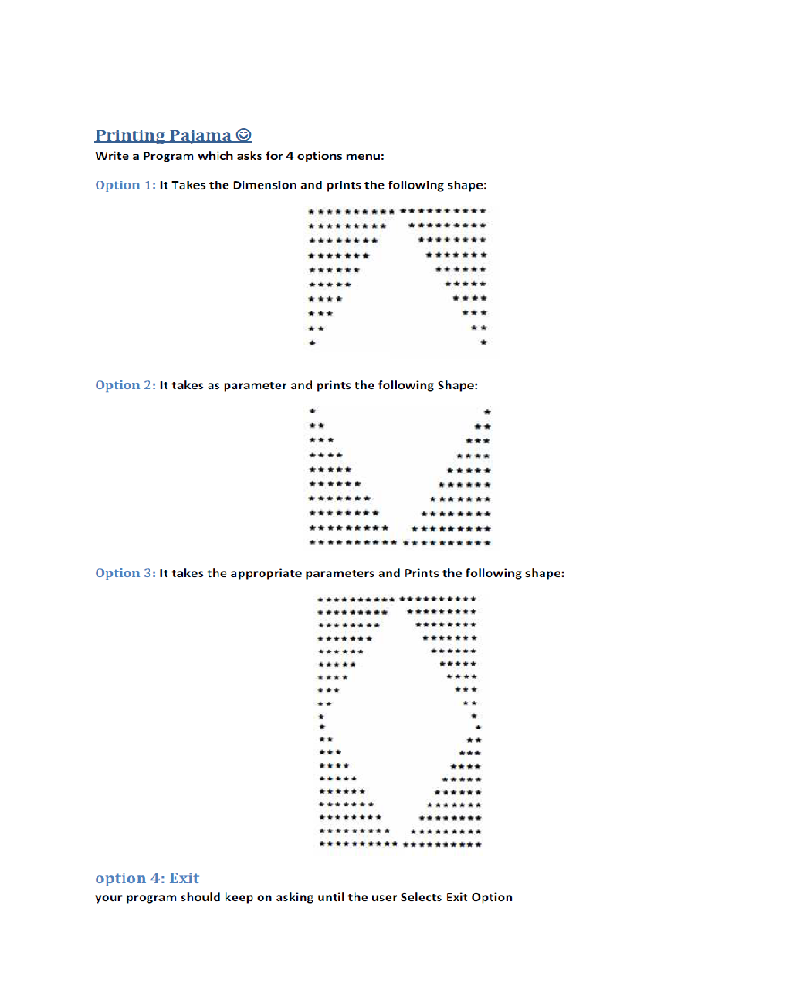
PART 2
Make hollow shapes pajamas

CHALLENGE 2
THE CHALLENGE - STAR


Pyramid of Letters…!!!
You need to make function PrintFirstKCharacters(int k)
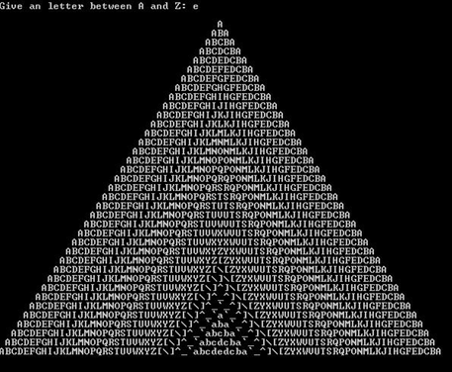

Part III
THIS ONWARD POST LAB CHALLENGES (Due before Next Lab)
Develop a program which takes the height of a triangle as input and print the triangle in the following fashion.
NOTE : You should make 4 functions
1 - For printing spaces
2 - For printing sequence of numbers in ascending order (from 1 to N)
3 - For printing sequence of numbers in descending order (from N to 1)
4 - For printing complete shape by calling the above mentioned functions
_______________________________________________________________________
Sample Input :
Enter the height of triangle : 6
Sample Output :
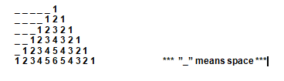
Part IV
Print the following shapes H = 5
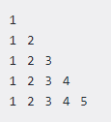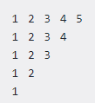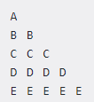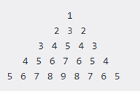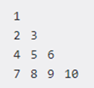
CHRISTMAS TREE
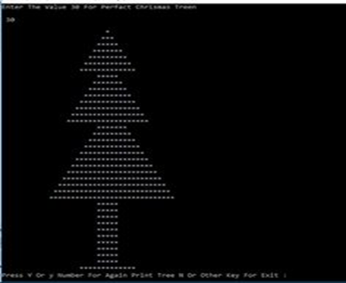

CHALLENGE 3

Challenge 3.1
Write a function which takes a number N and tells whether it is a circular prime or not. Read about the circular prime here https://en.m.wikipedia.org/wiki/Circular_prime

Challenge 3.2
Detect whether a number is a Truncatable prime or not.
https://en.m.wikipedia.org/wiki/Truncatable_prime

Challenge 3.3
Goldberg's conjecture is a famous mathematical statement which says the following any even number can be written as the sum of two prime numbers, write a program which first ask for a number K which means the user can give K even integers greater than 4 iteratively (in loop) and your program should display the two primes for every entered number which sum to the given number.

Challenge 3.4
Write a program which takes a range (two numbers R1 and R2) and report all twin primes between the given range. Twin primes are prime numbers which are consecutive odd numbers like 17, 19 similarly 29, 31 a d 41, 43.

